Lab 6: Algorithm Mining Using Phenomenology

Alexander Mervar

Indiana University

Lab 6: Algorithm Mining Using Phenomenology

**Section 1: Empirical**

Binocular rivalry is defined as the presence of two different stimuli presented to separate eyes, which creates a non-cohesive interpretation due to the lack of integration. When this takes place, it is common for someone responding to stimuli to report only seeing the image visible to one eye with the stimulus of the other eye completely suppressed. After a given amount of time has passed, subjects could possibly report switching to the other eye’s stimulus and suppressing the interpretation that was dominate moments before. In other instances, some subjects report an image being presented to them when pieces of each stimulus are mixed and create a stimulus that is hard to interpret due to an assortment of different visual features.

If one was to model this behavior, it would be important to gather phenomenological data by presenting various visual stimuli to the eyes. This can be done through the application of standard 3D glasses with a red filter over the left eye and a blue filter over the right. Once these stimuli are presented, the subject would record their experience and interpretation of the stimuli, which can then be used to generate a plausible model.

The stimuli that were presented to the subject were each made to try and create different behaviors and were made to discover different aspects for a possible model. The stimuli are as follows:

Figure A:

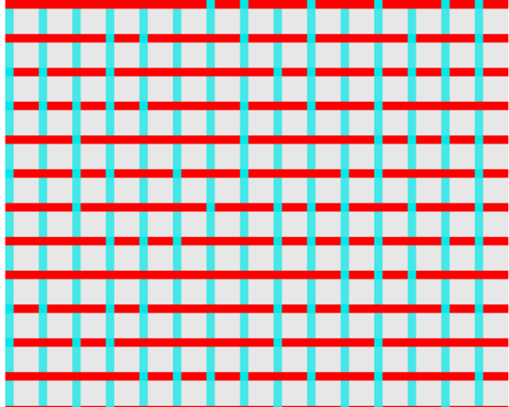

Figure B:

Figure C:

Figure D:

Figure E:

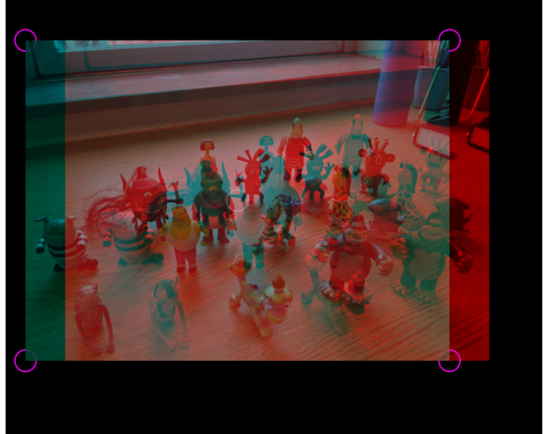

Figure F:

From these stimuli, the following phenomena were recorded: As predicted by many visual ocular dominance models, differing visual stimuli present to each eye creates a oscillating stimuli between one stimulus and another. Figure A had only horizontal stripes for 4-5 seconds before reverting to vertical stripes for 4-5 seconds. This behavior would continue ad infinitum. It was also noticed by the presentation of Figure B that when a stimulus is presented following constantly moving stimulus, that new stimulus goes unnoticed by the visual system. In figure C, depth was created by stimuli that were spatially close to one another if they were presented to different eyes. Figure D created an intentional spot in the visual field that was non-cohesive due to an non-cohesive stimuli being presented to the subject. But this effect was to a lesser extent than other phenomena. Finally, for figure E and F, there was a phenomenon reported that the left eye was slightly more dominant. In that way, the created model would be very similar to those that have come before it but it would need a temporal component as well as dominance towards the left eye, slightly.

**Section 2: Model**

The model proposed in built on top of the neural network model organized in this fashion:

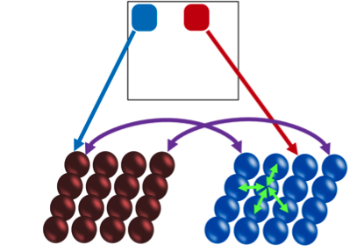

This model can touch on many of the phenomena already recorded, this model’s nodes in each eye interact with each other to cause the dominance effect. With the nodes surrounding a particular node impacting its own weight and vice versa. This model also considers the fact that the stimuli presented to both eyes is split between them due to the filters. Therefore, the only necessary addendums are the temporal and left eye dominance to have an encompassing and satisfying model.

The temporal aspect can simply be solved by the function that every 4 seconds, the dominance of one eye is overtaken by the dominance of the other. This goes against existing models, which predict that the typical visual system switches dominance every 30 seconds approximately. Then, to add dominance to the left eye, each left node has a weight multiplies by about 1.5x the weight of the right eye.

**Section 3: Application of Model to the Phenomenology**

Regarding the additional weight to the left eye, it seems to be in certain scenarios where depth is already present in a photo or similar stimuli. This will require additional investigation to flush out when this additional weight would be applied to the model. But, with the current stimuli on hand, this is an investigation that must be tabled for a later date. This is a fallacy of the model to this aspect being more vague and seemingly inconsistent with its application.

Where this model really exceeds and makes major strides is the addition of a temporal component more suited to the experiences of the phenomenological reportings of the subject. By having a much more rapid switch from eye to eye, the model can be more conclusive on how the subject viewed the stimuli.